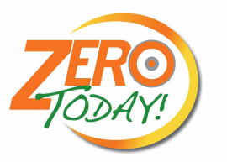 | Job / Task to be Performed |  |  |  |  |  |  |  | JHA #
 | Job Hazard Analysis (JHA) |  |  | Revised by:
Personal Protective Equipment Requirements |  | Hard Hat | Safety Glasses |  | Safety Shoes | Hearing Protection |  | Ice Grippers / spikes
 |  | Work Gloves | Back Support |  | Rubber Gloves | Goggles |  | Face Shield

Sequence of basic job steps |  | Potential Hazards | Recommended action or control
1 | Prior to start of work. | 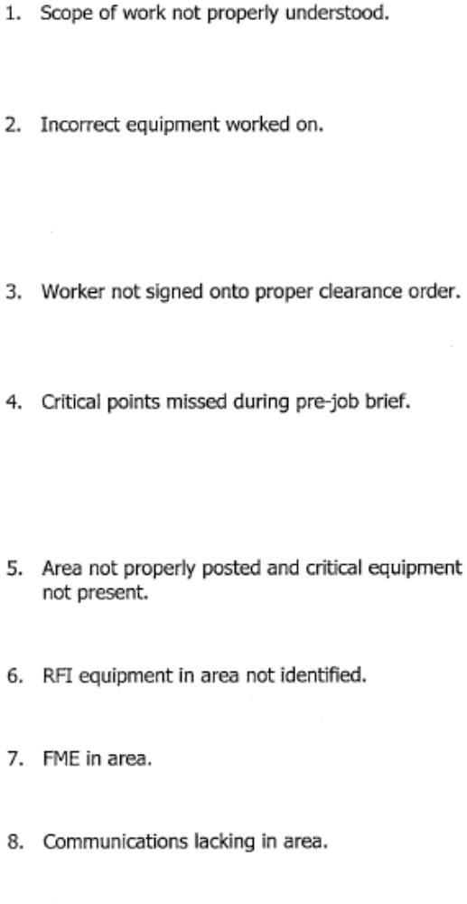 | 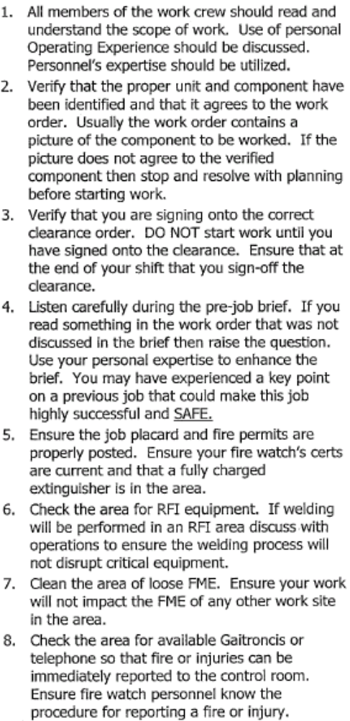

2 | Work Performance ( Safety) | Eye injury  Burns from active hot pipes  Miscellaneous hazards as outline in MSDS Cuts/Lacerations  Injuries caused by pinch points, blowing air from air drive ratchet, removal of pipe caps, valve manipulations, back injuries from bending and stooping below deckplates, removal of protective covers, trip hazards from air hoses, ear injury from loud noises, engaging and disengaging of jacking gear assembly. | Ensure that the proper type of eye protection has been selected for the risks associated with the job.  • Ensure that the proper PPE is worn and exposed skin is protected as needed.  Ensure that the proper PPE is worn and exposed skin is  Protected as needed.Refer to Dolphin (MSDS)  • Ensure that the proper type of gloves have been selected and available for the risks associated with the project.  Wear gloves for ALL activities involving manipulation of valves, tools pipe cap, jacking gear and protective cover removal and installation.  • Ensure Eye Protection is worn to prevent eye injury from flying debris.  • Use proper bending techniques ( bend with the knees) to avoid back injury. Move slowly.  • Use situational awareness to prevent trips and falls from air lines.  • Ensure proper hearing protection is used.  • Keep hands AWAY from contact points.  • Ensure Air Line is DEPRESSURIZED prior to removal.
3 | Work completions. | 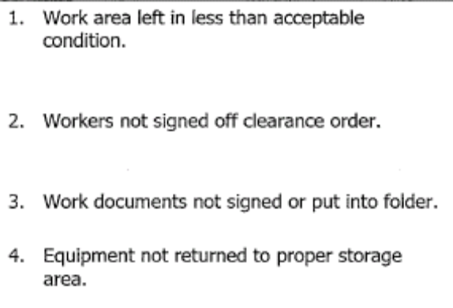 | 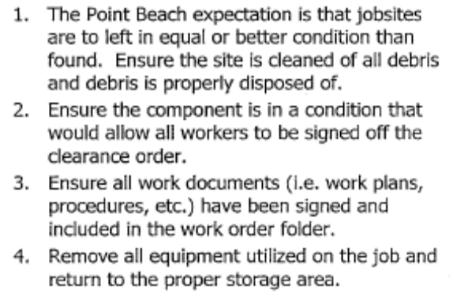
4
5

Prior to starting the job a pre-job brief will take place for the assigned craft personnel to review the JHA, upon completion of the review the assigned craft will sign off on the JHA.

Signature | Date

